INSTALLATION AND INTERFACE GUIDE
RDM6300 Card Reader
Raspberry Pi Installation & HTTP API Reference

Document version | 1.0
Release date | 06 October 2026
Applies to | rdm-card-reader 0.4.0 and later
Owner | Engineering
Classification | Internal

This guide covers the complete deployment of the RDM6300 125 kHz card reader on Raspberry Pi OS: enabling the serial interface, wiring and mounting the hardware, installing the service, and consuming card events through the HTTP API.

Document control
This document is maintained under version control alongside the source code. Record revisions in the table below.
Table 1 — Revision history
Version | Date | Author | Summary of change
1.0 | 06 October 2026 | Engineering | First issue. Covers installation on Raspberry Pi OS and the complete HTTP API.

Reference documents
Reference | Title | Purpose
[RD1] | README.md | Primary product documentation in the source repository
[RD2] | LAUNCH.md | Startup sequence and offline install notes
[RD3] | deploy/install.sh | Reference installation script
[RD4] | deploy/rdm-card-reader.service | systemd unit template

Conventions
- Command-line input is shown in a shaded block and is intended to be typed or pasted into a terminal on the Raspberry Pi.
- Bold text marks interface elements, option names and values that must be chosen exactly.
- Monospaced text marks file paths, device nodes, flags and JSON fields.
- Callouts flag information that changes the outcome of a step: Note, Important and Verified.
Scope. Card identifiers are the only data this system produces, and the system does not decide which person a card belongs to. User lookup remains the responsibility of the calling application.

Contents

1 Introduction 5
1.1 Purpose 5
1.2 Audience 5
1.3 Terminology 5
2 System overview 6
2.1 Function 6
2.2 Startup sequence 6
2.3 Integration model 6
3 Prerequisites 7
3.1 Hardware 7
3.2 Software 7
3.3 Before you begin 7
4 Enabling serial communication on Raspberry Pi OS 8
4.1 Enable the serial port 8
4.2 Verify the port 8
4.3 Confirm the console is not holding the port 9
4.4 Grant the logged-in user access (optional) 9
5 Wiring, GPIO reference and mounting 10
5.1 GPIO pinout reference 10
5.2 Identifying the header 11
5.3 Reader connection (UART) 12
5.4 Level compatibility 12
5.5 LED connection 12
5.6 Physical mounting 13
6 Installation 15
6.1 Copy the project to the Raspberry Pi 15
6.2 Run the installer 15
6.3 Installer options 16
6.4 What the installer does 16
6.5 Re-running the installer 17
7 Features and operating modes 18
7.1 Output modes 18
7.2 Status and error LEDs 18
7.3 Status page 18
7.4 Remote access and tokens 19
7.5 Reader modes 19
7.6 Offline dependency installation 19
8 HTTP API reference 21
8.1 Base URL and protocol 21
8.2 Authentication and cross-origin policy 21
8.3 Endpoint summary 21
8.4 Endpoint reference 22
8.4.1 GET /api/health 22
8.4.2 GET /api/card 22
8.4.3 POST /api/card/claim 23
8.4.4 GET /api/events 24
8.4.5 GET /api/last and GET /api/taps 24
8.4.6 POST /api/mode 24
8.4.7 GET and POST /api/led 24
8.5 Card data model 24
8.6 Timers 25
8.7 Status codes 26
8.8 Integration example 26
8.9 Security considerations 27
9 Verification and acceptance testing 28
9.1 Acceptance checklist 28
9.2 Step-by-step verification 28
9.3 Verifying the LEDs 29
10 Troubleshooting 30
10.1 Serial and device 30
10.2 Reading cards 30
10.3 LED 31
10.4 API 31
11 Maintenance and operations 31
11.1 Service management 31
11.2 Applying updates 32
11.3 Complete removal 32
11.4 Backing up configuration 32
Appendix A — Command-line reference 33
Appendix B — Exit codes 35
Appendix C — LED pin numbering 35
Appendix D — Serial protocol 36
Appendix E — Source layout 36
Page numbers refer to the printed page numbers in the footer.

1 Introduction

1.1 Purpose
This document provides the procedure to install, configure and verify the RDM6300 card reader on a Raspberry Pi, and a complete reference for the HTTP API it exposes. Following it end to end produces a reader that reports card taps to a web application over the local network.

1.2 Audience
The document addresses two audiences:
- Field engineers and technicians installing the hardware and service. Sections 3 to 6 and 9 are sufficient.
- Application developers integrating with the reader. Sections 7 and 8 provide the interface contract.

1.3 Terminology
Table 2 — Terminology
Term | Meaning
RDM6300 | The 125 kHz RFID reader module. Transmit-only: it emits card frames on a serial line and never receives.
EM4100 | The card format the reader understands. A card broadcasts a fixed 40-bit identifier.
Bridge | The HTTP service started by the --serve option. It publishes card taps to web clients.
Latch | The short period for which a tap is retained so a page that polls late still sees it.
Claim | A single-use action that consumes a latched tap for one authentication, so one tap cannot log in twice.
Tap | One presentation and read of a card.
UART | The Pi's on-board serial port, exposed as /dev/serial0.

2 System overview

2.1 Function
An RDM6300 module reads 125 kHz EM4100 cards and transmits each read as a serial frame. The application on the Raspberry Pi decodes those frames and either prints them, or — in --serve mode — publishes them over HTTP so a web page can authenticate the tap.
A card is reported once when presented and once when removed. The reader library de-duplicates the repeated frames a card produces while it sits on the antenna.

2.2 Startup sequence
The application performs four steps at start-up:
Step 1. Check dependencies. If the rdm6300 or pyserial libraries are missing they are installed from wheels bundled in the package, with no network access required.
Step 2. Find the reader. Resolve the serial port and open it, identifying a USB adapter by serial number or by-id path rather than trusting ttyUSB0.
Step 3. Start reading. Read frames continuously; each valid frame becomes a card event.
Step 4. Publish. In --serve mode the event is latched for the web client to claim.
Fail loudly. Steps 1 and 2 refuse to start half-configured and report the reason. A reader that silently selects the wrong port is treated as worse than one that declines to start.

2.3 Integration model
The bridge is deliberately narrow: it reports card identifiers and nothing else. Resolving an identifier to a user, and granting a session, is the caller's job. The sequence below shows the full exchange.
Figure 1 — Tap-to-login sequence
Card Reader service (Pi) Web page Your server
| | | |
|--- tap ------------>| | |
| |-- latch tap (tap-ttl) | |
| |<-- GET /api/card -----| |
| |--- {present, card} -->| |
| |<-- POST /api/card/claim |
| |--- {card, consumed} ->| |
| | |--- POST /login ---->|
| | |<-- session ---------|

3 Prerequisites

3.1 Hardware
Table 3 — Bill of materials
Item | Specification | Notes
Raspberry Pi | Pi 1–5, any model | Pi 5 uses GPIO chip 4; earlier models use chip 0. Handled automatically.
RDM6300 reader | 125 kHz, EM4100 cards | Supplied with a coil antenna.
Cards | EM4100 / 125 kHz | 125 kHz only. 13.56 MHz (MIFARE) cards are not readable.
Status LED | 5 mm, ~330 Ω resistor | Optional. GPIO 23 by default.
Error LED | 5 mm, ~330 Ω resistor | Optional. GPIO 24 by default.
Level shifter | Divider or shifter | Strongly recommended. See section 5.4.
Power supply | 5 V, 2.5 A or better | Per Raspberry Pi model.
microSD card | 8 GB or larger | Raspberry Pi OS Bookworm or later.

3.2 Software
- Raspberry Pi OS (Bookworm or later recommended; Bullseye is supported).
- Python 3.8 or later, present in Raspberry Pi OS by default.
- Network access is optional. All runtime dependencies ship inside the package.
- Administrative (sudo) access on the Pi.

3.3 Before you begin
Check | Command | Expected
Operating system | cat /etc/os-release | head -2 | Debian/Raspberry Pi OS release name
Python version | python3 --version | 3.8 or later
Administrative access | sudo -v | No error
GPIO group present | getent group gpio | A gpio entry (Bookworm+)

4 Enabling serial communication on Raspberry Pi OS
The reader is connected to the Pi's on-board UART. That interface is disabled by default on Raspberry Pi OS, and /dev/serial0 does not exist until it is switched on. This section is a prerequisite for the installation in section 6.

4.1 Enable the serial port
Step 1. Open the configuration tool. Run sudo raspi-config on the Pi.
Step 2. Select **Interface Options**, then **Serial Port**. Menu numbering differs between releases, so navigate by name rather than by position.
Step 3. Answer the first question **No**. "Would you like a login shell to be accessible over serial?" A login shell occupies the port and prevents the reader from using it.
Step 4. Answer the second question **Yes**. "Would you like the serial port hardware to be enabled?"
Step 5. Reboot. Run sudo reboot and allow the Pi to restart.
Important — both answers matter. Answering Yes to the login shell is the most common cause of a reader that opens the port and then never sees a card, or reports the device as not found.

4.2 Verify the port
After the reboot, confirm the device node exists:
ls -l /dev/serial0 /dev/rdm-reader 2>&1
Table 4 — Interpreting the device nodes
Result | Meaning | Device to pass
/dev/serial0 -> ttyAMA0 (or ttyS0) | On-board UART, header pins 8 / 10 | /dev/serial0
/dev/rdm-reader | USB-to-serial adapter | /dev/rdm-reader
No such file or directory | Nothing openable yet — see section 10 | Investigate first

The two are mutually exclusive. /dev/rdm-reader is created by a udev rule that matches a USB bridge chip, so it can never exist for the on-board UART. A service configured with the wrong value exits with code 1 on every start.

4.3 Confirm the console is not holding the port
If a serial console is still attached, the reader receives nothing. Check both of the following:
sudo systemctl is-active serial-getty@ttyAMA0.service # must NOT be active
grep -o 'console=[^ ]*' /boot/firmware/cmdline.txt # must NOT reference serial0
If either check fails, re-run sudo raspi-config and confirm the answers in section 4.1, then reboot.

4.4 Grant the logged-in user access (optional)
Useful when running the application by hand rather than as a service. The installer grants the *service* account this group automatically.
sudo usermod -aG dialout $USER # then log out and back in

5 Wiring, GPIO reference and mounting
The RDM6300 communicates over plain serial at 9600 baud, 8N1. This section maps the physical header, the reader connection and the optional LEDs, and shows the mechanical mounting.

5.1 GPIO pinout reference
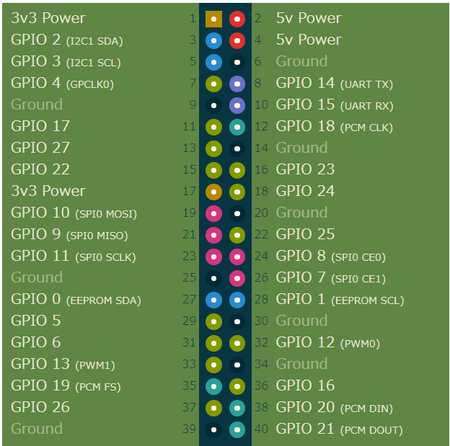
Figure 2 — Raspberry Pi 40-pin GPIO header layout (pinout_layout.png). BCM GPIO numbers are shown inside the header; physical pin numbers are shown outside.

5.1.1 Connections used by this reader
Figure 3 marks the pins this installation uses on the header diagram supplied with the product. The legend below it repeats the mapping in text.
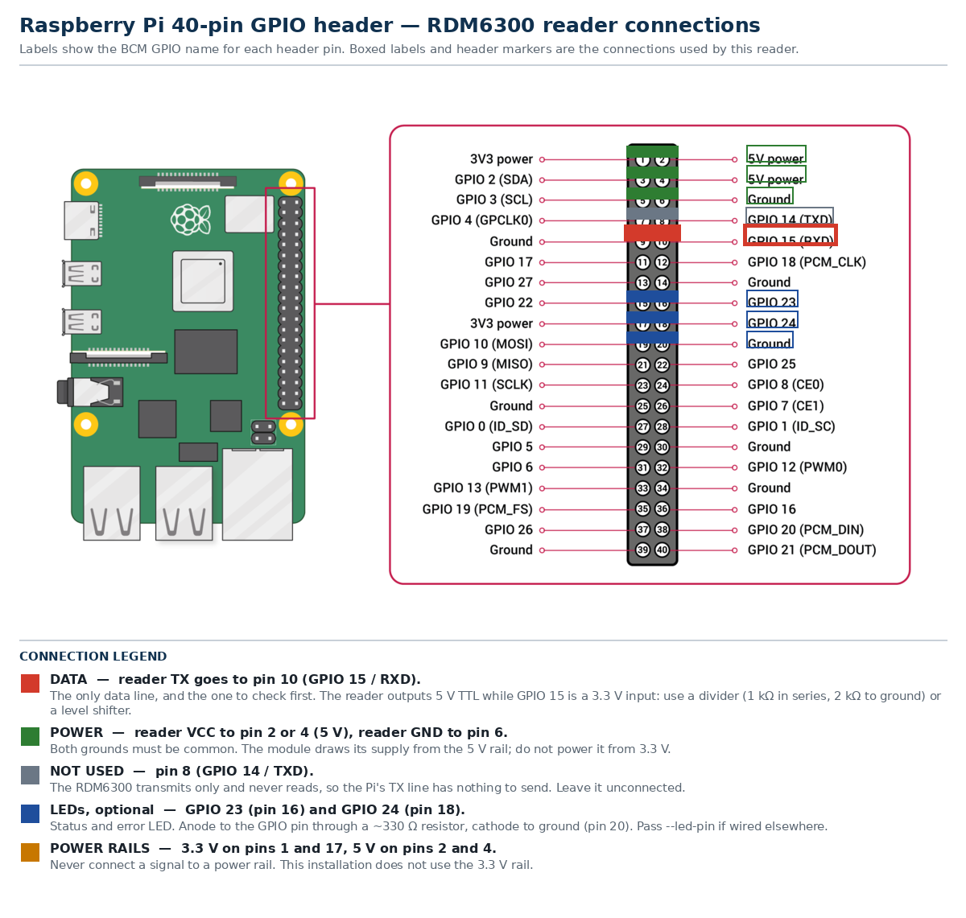
Figure 3 — Annotated header diagram (rpi+gpio.png). Boxed labels and header markers show the reader's data, power, ground and LED connections; pins shown in grey are not used.

5.2 Identifying the header
Locate physical pin 1, marked by the square pad at the corner of the header nearest the microSD slot. Standard Pi models present 40 pins in two rows of 20.
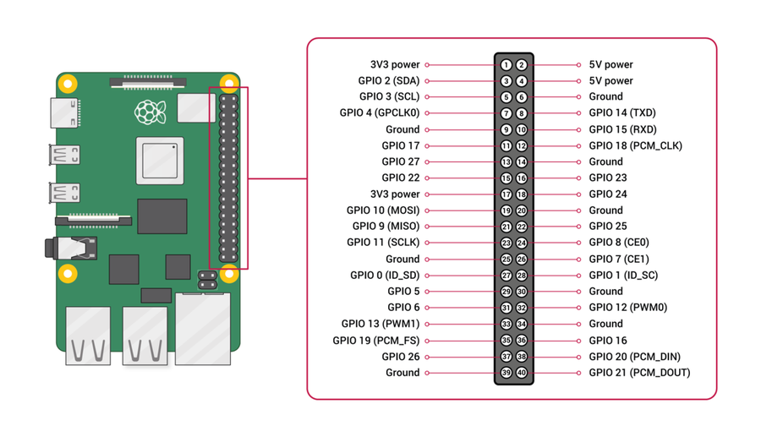
Figure 4 — Raspberry Pi board with the GPIO header identified

5.3 Reader connection (UART)
Table 5 — RDM6300 to Raspberry Pi header
RDM6300 | Pi pin | Signal | Direction
VCC (5 V) | 4 | 5 V power | Pi → reader
GND | 6 | Ground — must be common | —
TX | 10 (GPIO 15, RXD) | Card data | reader → Pi
RX | 8 (GPIO 14, TXD) | Not used | —

The reader is transmit-only: it emits frames continuously and never reads. Only pin 10 carries data, and the Pi's TX line on pin 8 has nothing to send.

5.4 Level compatibility
Important — voltage levels. The RDM6300 TX output is 5 V TTL, while GPIO 15 is a 3.3 V input. Driving it directly often appears to work but stresses the pin. Use a divider (for example 1 kΩ in series and 2 kΩ to ground) or a level shifter on the reader TX → pin 10 line.

5.5 LED connection
Both LEDs are optional; the reader functions without them. Each LED is wired anode → GPIO pin through a ~330 Ω resistor, cathode → GND.
Table 6 — LED assignments
LED | Default GPIO (BCM) | Physical pin | Indicates
Status | 23 | 16 | A card is on the reader (presence mode)
Error | 24 | 18 | A read failed (checksum mismatch)

BCM number, not header pin. The --led-pin option takes the BCM GPIO number. The default 23 corresponds to physical pin 16, not physical pin 23. Confusing the two is the single most common cause of a dark LED with no error reported. The mapping is given in Appendix C.

Where the LED is driven by a transistor or MOSFET that inverts the signal, or the LED is wired cathode-to-pin and anode-to-3.3 V, pass --led-active-low so the logic is inverted.

5.6 Physical mounting
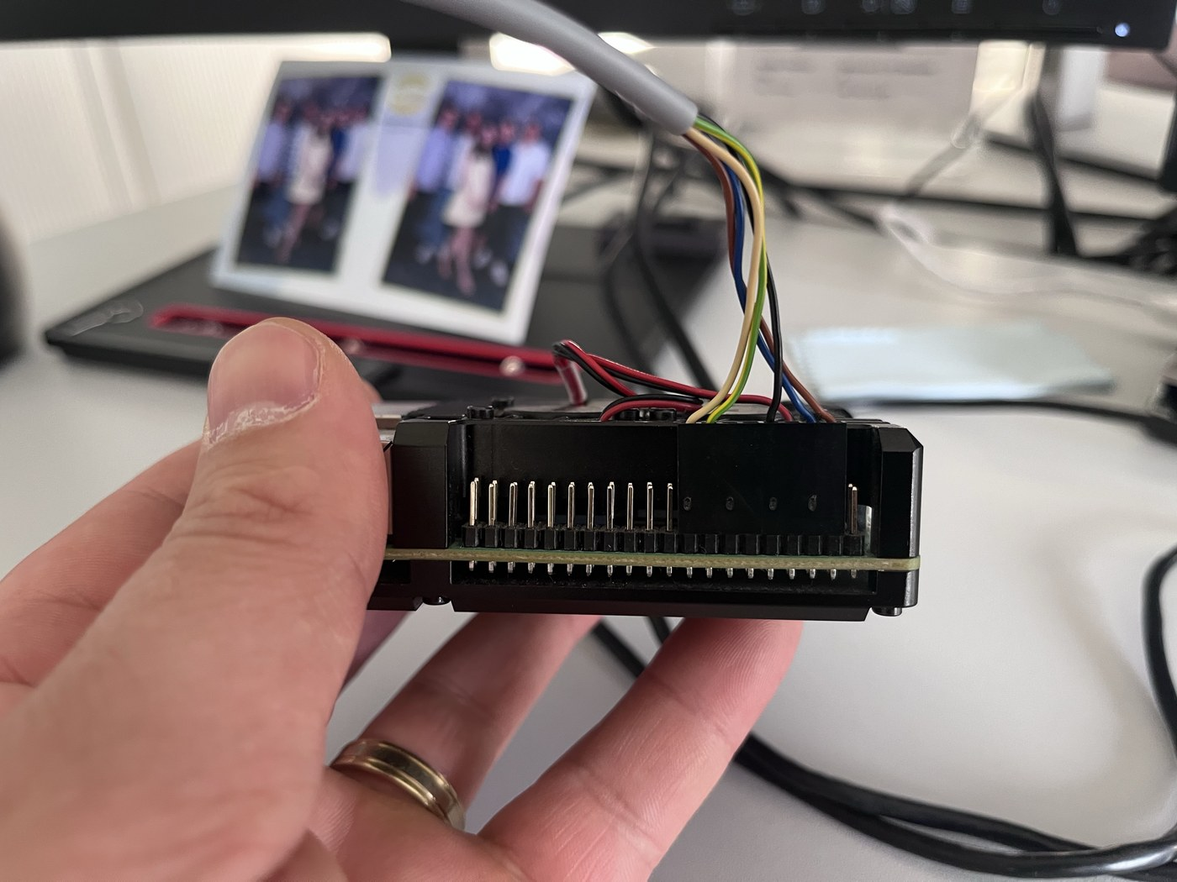
Figure 5 — Reader module mounted on the Raspberry Pi (reader_mount.jpg). The coil antenna is positioned clear of the board and of metalwork.
- Keep the reader clear of the Pi's metalwork, mounting posts and cables; metal near the coil reduces read range.
- Hold the card approximately 2 cm from the coil for a reliable read.
- Keep the reader-to-Pi cabling short and, where possible, shielded. Long or unshielded wiring increases checksum errors.
- Route the reader cable away from the mains wiring and the Pi's power supply to limit electrical noise.

6 Installation
The installation consists of copying the project directory to the Pi and running the installer. The installer creates a service account, a virtual environment, a udev rule and a systemd unit, then enables the service.

6.1 Copy the project to the Raspberry Pi
Choose one of the two methods below. The project directory contains deploy/, src/, pyproject.toml and the documentation; the installer resolves its own location, so the folder may be copied anywhere.
Method A — transfer from a workstation with SCP.
# From the workstation, in the parent of the project folder:
scp -r rdm-card-reader pi@192.168.0.228:/home/pi/
ssh pi@192.168.0.228
Method B — clone from the Git repository.
# On the Raspberry Pi:
sudo apt-get install -y git
git clone https://gitea.moto-adv.com/ske087/rdm-card-reader.git
cd rdm-card-reader
No internet on the Pi? Use Method A. The runtime libraries are bundled in src/rdm_card_reader/wheels/, so the installer does not need network access.

6.2 Run the installer
The defaults suit the wiring described in section 5: /dev/serial0 for the reader on the UART, and GPIO 23 for the status LED. Run the installer with administrative privileges.
Step 1. Change into the project directory. cd rdm-card-reader
Step 2. Run the installer. Pass the device that matches your wiring (section 4.2).
sudo ./deploy/install.sh --device /dev/serial0 --origin https://your.web.app
For a USB-to-serial adapter, substitute the device:
sudo ./deploy/install.sh --device /dev/rdm-reader --origin https://your.web.app
Verified at install time. The installer refuses to enable the service unless the device both exists and opens at 9600 baud, so a wrong port fails during installation instead of becoming a unit that restarts until it is rate-limited. Success is reported as /dev/serial0 opened at 9600 baud.

6.3 Installer options
Table 7 — Installer options
Option | Default | Purpose
--device PATH | /dev/serial0 | Serial device the service opens.
--origin URL | — | Web origin permitted to call the API. Repeatable.
--led-pin N | 23 | BCM GPIO number of the status LED.
--led-mode M | presence | presence lights while a card is present; error lights whenever running.
--led-active-low | off | Invert the status LED signal.
--error-led-pin N | 24 | BCM GPIO of the error LED.
--error-led-active-low | off | Invert the error LED signal.
--no-error-led | off | Blink the status LED instead of using a second LED.
--error-pulse S | 1.0 | Seconds the error LED stays lit.
--heartbeat S | 2.0 | Seconds before a silent reader is treated as card removal.
--port PORT | 8765 | HTTP port for the bridge.
--host ADDR | 127.0.0.1 | Bind address. Loopback only unless --allow-remote is given.
--allow-remote | off | Permit a non-loopback bind address.
--token SECRET | — | Token required from non-loopback callers. See section 7.4.
--dir PATH | /opt/rdm-card-reader | Install location.
--user NAME | rdmcard | Service account name.
--no-service | off | Install and configure without enabling the service.

6.4 What the installer does
- Installs system packages and the GPIO pin backend required by the LEDs (python3-lgpio on Bookworm and later, python3-rpi.gpio on older releases) when neither is importable.
- Copies the project to /opt/rdm-card-reader and creates a virtual environment that can see the system GPIO libraries.
- Installs the runtime libraries from the bundled wheels.
- Creates the rdmcard service account and adds it to the dialout and gpio groups.
- Installs the udev rule that provides the stable /dev/rdm-reader alias for USB adapters.
- Writes and enables the systemd unit rdm-card-reader.service.
The unit runs the following command:
/opt/rdm-card-reader/.venv/bin/rdm-card-reader \
--serve --port <device> --bridge-port 8765 --mode login \
--led-pin <pin> --led-mode <mode> --heartbeat <seconds>

6.5 Re-running the installer
The account, udev rule and virtual environment are all idempotent, so re-running the installer is safe and is the supported way to change options. Re-running also picks up the updated unit definition.

7 Features and operating modes

7.1 Output modes
In its default mode the application prints a human-readable block for each event. With --json it prints one JSON object per line, which is the form to use when piping into another program.
{"event": "card_inserted", "timestamp": "2026-10-01 14:56:54", "id": 12886197, "hex": "0x00C4A0B5", "type": 15, "checksum": 222, "is_valid": true, "port": "/dev/ttyAMA0"}
Without --serve the events go to standard output, which for a service means the system journal.

7.2 Status and error LEDs
Two LEDs, each carrying one message, control the state of the reader at a glance. Both are optional.
Table 8 — Status LED modes
Mode | Behaviour | Use when
presence (default) | Lit only while a card is on the reader. | The light should mean “a card is here”.
error | Lit whenever the reader is running; blinks on a failed read. | The light should mean “the reader is alive and ready”.

A dark LED at start-up is expected. In presence mode the LED is dark until the first valid read. Confirm that reading a card lights it before concluding the LED is faulty.

The LED subsystem is designed so that it can never compromise reading:
- Never blocks. Every change is queued to a worker thread, so a toggle returns immediately even with slow hardware.
- Never fatal. Where no GPIO is available the application falls back to a no-op LED and reports why.
- Never crashes on a dead pin. A failed toggle is logged and ignored.
Start-up reports the state of each LED in the journal:
LED on GPIO 23 (presence mode, active-high, gpiozero)
Error LED on GPIO 24 (lit for 1.0s on a bad read, ...)
LED unavailable: gpiozero not installed
LED unavailable: no usable GPIO on pin 23: ...

7.3 Status page
Serving places a read-only status page at GET / on the bridge port, showing the mode, port, uptime, whether a card is present and claimable, the current card, event counters and a live event log.
http://127.0.0.1:8765/
The log is seeded with recent history and then updated live over a server-sent events stream, so it keeps filling without a refresh. Disable the page with --no-page to serve the API only.
The page never claims a tap. It deliberately has no claim control, because claiming spends the tap and a page that claimed would consume a real login merely by being open. Claim from the calling application instead.

7.4 Remote access and tokens
The bridge binds to loopback only by default. Reaching it from another machine requires an explicit opt-in and a token.
sudo ./deploy/install.sh --device /dev/serial0 \
--host 0.0.0.0 --allow-remote --token 'pick-a-long-secret'
The installer refuses a non-loopback address without --allow-remote and warns when no token is given. The token is written to /opt/rdm-card-reader/bridge.env at mode 0600 and referenced by the unit through EnvironmentFile=, rather than appearing on the command line where the process list and systemctl cat would reveal it.
Exposure. Off loopback, anyone who can reach the port can read card taps and switch the LEDs. A card identifier is an identifier, not a password. Keep the bridge on a trusted network and set a token.

Loopback callers never need the token, so local tools and curl continue to work unchanged. An alternative that avoids exposing the port entirely:
ssh -N -L 8765:127.0.0.1:8765 pi@192.168.0.228
# then browse http://127.0.0.1:8765/ on the workstation

7.5 Reader modes
Mode | Publishes | Use when
login (default) | Card taps only. | A tap is an authentication attempt.
monitor | Taps and removals. | Watching a reader rather than logging people in.

7.6 Offline dependency installation
The rdm6300 and pyserial wheels ship inside the package, so a device with no internet can still install them. On first start the application installs anything missing, using --no-index so no route to PyPI is required.
- Nothing is installed when the libraries are already present.
- Wheels are verified against a bundled SHA256SUMS before installation; a wheel that fails its checksum is refused.
- A failed install does not crash the application: it exits with code 2 and prints the exact command to run by hand.

8 HTTP API reference

8.1 Base URL and protocol
All endpoints are served over HTTP on the bridge port, 8765 by default. Requests and responses use JSON with Content-Type: application/json. The API is available only when the application runs with --serve.
http://<pi-address>:8765/api/...
When the bridge is bound to loopback (the default), replace <pi-address> with 127.0.0.1 and call from the Pi, or use the SSH tunnel described in section 7.4.

8.2 Authentication and cross-origin policy
Table 9 — Access controls
Control | Behaviour
Bind address | 127.0.0.1 by default. Any other address requires --allow-remote.
Origins | Cross-origin browser requests are refused unless the exact origin is listed with --allow-origin.
Token | Required from non-loopback callers. Send the header X-Auth-Token, or use the token query parameter.
Health endpoint | GET /api/health is answered before the origin and token checks, so monitoring can always reach it.

# Authenticated request from another machine
curl -sS -H "X-Auth-Token: SECRET" http://192.168.0.228:8765/api/card

8.3 Endpoint summary
Table 10 — Endpoint summary
Method | Path | Purpose | Auth
GET | / | Status page (unless --no-page) | per policy
GET | /api/health | Liveness and state — no auth check | none
GET | /api/card | The latched tap | per policy
POST | /api/card/claim | Spend the tap on one login | per policy
GET | /api/events | Server-sent event stream | per policy
GET | /api/last | Most recent card event, or 204 | per policy
GET | /api/taps | Recent tap history (?limit=N) | per policy
POST | /api/mode | Switch login / monitor | per policy
GET | /api/led | Both LEDs: pin, polarity, state | per policy
POST | /api/led | Drive an LED by hand, or release | per policy

8.4 Endpoint reference

8.4.1 GET /api/health
Liveness and diagnostic state. Answered before the origin and token checks, so it remains readable by any client that can reach the port.
curl -sS http://127.0.0.1:8765/api/health
Response 200
{
"status": "ok",
"port": "/dev/serial0",
"mode": "login",
"uptime_seconds": 128.4,
"subscribers": 1,
"counts": { "card_inserted": 4, "card_removed": 3 },
"last_tap": { "event": "card_inserted", "id": 12886197, "...": "..." },
"last_tap_age_seconds": 12.1,
"card_present": false,
"card_consumed": false,
"tap_ttl_seconds": 10,
"claimed_ttl_seconds": 30
}

8.4.2 GET /api/card
The latched tap — the endpoint a page polls to discover whether a card has been presented and can still be claimed.
Table 11 — /api/card fields
Field | Type | Meaning
present | boolean | The card is physically on the reader right now.
claimable | boolean | This tap can still be spent on a login.
consumed | boolean | The tap has already been claimed.
expired | boolean | The tap aged past --tap-ttl.
age_seconds | number | Age of the tap, or null.
card | object | The card, or null. See section 8.5.

Response 200
{
"present": true,
"claimable": true,
"consumed": false,
"expired": false,
"age_seconds": 1.4,
"card": { "id": 12886197, "hex": "0x00C4A0B5", "...": "..." }
}
“Present” and “card” answer different questions. present becomes false the moment the card is lifted, while card retains the latched identifier. A card tapped and removed a second ago therefore reports present: false with card still populated. That is correct: if the identifier vanished with the card, any poll arriving after the lift could not authenticate anything.

8.4.3 POST /api/card/claim
Atomically claims the latched tap for one authentication. The tap is marked used only when the call succeeds, so two concurrent requests cannot both win.
curl -sS -X POST http://127.0.0.1:8765/api/card/claim
Response 200
{
"card": { "id": 12886197, "hex": "0x00C4A0B5", "...": "..." },
"age_seconds": 1.4,
"consumed": true
}
Status | Condition | Body
409 | No tap has been read yet | {"error": "no card read yet"}
409 | The tap was already claimed | {"error": "card already used"}
410 | The tap aged past --tap-ttl | {"error": "card tap expired"}

8.4.4 GET /api/events
A server-sent events stream that pushes each event as it happens, removing the need to poll.
const events = new EventSource("http://127.0.0.1:8765/api/events");
events.onmessage = (e) => { const tap = JSON.parse(e.data); /* tap.id */ };

8.4.5 GET /api/last and GET /api/taps
/api/last returns the most recent card event, or 204 No Content when there has been none. /api/taps returns recent history and accepts ?limit=N (default 20).

8.4.6 POST /api/mode
curl -sS -X POST -H 'Content-Type: application/json' \
-d '{"mode": "monitor"}' http://127.0.0.1:8765/api/mode
Valid values are login and monitor. An invalid value returns 400 with the list of valid modes.

8.4.7 GET and POST /api/led
Read or drive the LEDs directly. This exists so an operator can establish whether the software can drive the pin at all. A forced state is held until it is released.
curl -sS http://127.0.0.1:8765/api/led
curl -sS -X POST -H 'Content-Type: application/json' \
-d '{"led":"status","on":true}' http://127.0.0.1:8765/api/led
curl -sS -X POST -H 'Content-Type: application/json' \
-d '{"release":true}' http://127.0.0.1:8765/api/led
Status | Condition
400 | Malformed JSON body, or a body that does not match the expected shape
409 | The named LED is not available; the response carries the reason
503 | LED control is not available at all

8.5 Card data model
A card object appears in /api/card, /api/card/claim, /api/last and /api/taps, and has the following shape.
Table 12 — Card object
Field | Type | Meaning
id | integer | Decimal card identifier — the number printed on the card
hex | string | The same identifier in hexadecimal
type | integer | Card type / version byte
checksum | integer | Frame checksum, validated on receipt
is_valid | boolean | Whether the frame passed validation
port | string | Serial port the card was read on
event | string | card_inserted or card_removed
timestamp | string | Time of the event

8.6 Timers
Two independent windows govern how long a tap remains readable.
Table 13 — Tap windows
Window | Option | Default | Governs
Unclaimed | --tap-ttl | 10 s | How long a tap can still be spent on a login.
Claimed | --claimed-ttl | 30 s | How long a claimed card stays readable so the claiming page can confirm which card logged in.

Setting either value to 0 disables that expiry. The state machine for /api/card is:
Table 14 — /api/card state machine
Moment | `present` | `card` | `claimable` | `consumed`
Card held on the reader | true | id | true | false
Lifted, within --tap-ttl | false | id | true | false
Claimed, within --claimed-ttl | false | id | false | true
After the claimed window | false | null | false | false
Unclaimed past --tap-ttl | false | null | false | false

Keep `--tap-ttl` at least as long as `--heartbeat`. They are independent. If the tap expires before the heartbeat declares the card removed, a card still on the reader has its identifier cleared and reads as "card": null until the next re-read. Matching them — for example --heartbeat 10 --tap-ttl 10 — avoids the gap for a card held in place.

8.7 Status codes
Table 15 — HTTP status codes
Code | Meaning | Typical cause
200 | Success | —
204 | No content | /api/last with no events yet
400 | Bad request | Malformed JSON body, or an invalid mode
401 | Unauthorized | Missing or invalid token from a non-loopback caller
403 | Forbidden | Cross-origin request from an origin not in --allow-origin
404 | Not found | Unknown path
409 | Conflict | The tap was already used, or is not available
410 | Gone | The tap expired before it was claimed
503 | Unavailable | LED control is not available

8.8 Integration example
Polling, claim, and hand the identifier to your own backend:
const state = await (await fetch("http://127.0.0.1:8765/api/card")).json();
if (state.claimable) {
const res = await fetch("http://127.0.0.1:8765/api/card/claim", { method: "POST" });
if (res.ok) {
const { card } = await res.json();
await fetch("/login/card", { // your server decides who card.id is
method: "POST",
headers: { "Content-Type": "application/json" },
body: JSON.stringify({ card_id: card.id, hex: card.hex }),
});
}
}
To confirm which card was used after a claim, read the identifier that remains available for --claimed-ttl:
const { card, consumed } = await (await fetch("http://127.0.0.1:8765/api/card")).json();
if (consumed && card) console.log("that tap was card", card.id);

8.9 Security considerations
Card identifiers are not secrets. An EM4100 card broadcasts a fixed 40-bit identifier with no challenge-response, and clones are inexpensive. Holding an identifier is therefore equivalent to knowing a number. Treat card authentication as identification and require an additional factor, such as a PIN, for anything sensitive.

- Bind address. Loopback by default; a non-loopback address requires an explicit opt-in.
- Origins. Cross-origin browser reads are refused unless the origin is explicitly allowed.
- Token. Pre-shared secret required from non-loopback callers, stored at mode 0600.
- Single use. A tap produces at most one successful claim.
- Bounded retention. A claimed identifier is cleared after --claimed-ttl, so an identifier that can no longer be acted on is never left in a response.

9 Verification and acceptance testing
Perform the checks below in order after installation. Each has an observable, binary outcome.

9.1 Acceptance checklist
Table 16 — Acceptance checklist
# | Check | Command | Expected result
1 | Service is running | systemctl is-active rdm-card-reader | active
2 | Service is enabled at boot | systemctl is-enabled rdm-card-reader | enabled
3 | Serial port opened | journalctl -u rdm-card-reader | grep -i opened | Port opened at 9600 baud
4 | Bridge is listening | ss -ltnp | grep 8765 | Listener present on port 8765
5 | Health endpoint responds | curl -sS http://127.0.0.1:8765/api/health | "status": "ok" with rising uptime_seconds
6 | Status page loads | Open http://127.0.0.1:8765/ in a browser | Page shows mode, port and uptime
7 | Card is detected | Read /api/card after presenting a card | present: true, claimable: true, card.id populated
8 | Tap can be claimed | curl -sS -X POST .../api/card/claim | 200 with consumed: true
9 | Tap cannot be claimed twice | Repeat the claim immediately | 409 card already used
10 | LED responds | POST /api/led {"led":"status","on":true} | The status LED lights
11 | Events stream | Open /api/events in a browser | Live events appear on each tap

9.2 Step-by-step verification
Step 1. Confirm the service is healthy. Two active states and an opened port.
systemctl is-active rdm-card-reader
systemctl is-enabled rdm-card-reader
journalctl -u rdm-card-reader -n 20 --no-pager
Step 2. Confirm the bridge answers. A rising uptime_seconds proves the process is serving, not just listening.
curl -sS http://127.0.0.1:8765/api/health
Step 3. Present a card and confirm detection. Hold an EM4100 card about 2 cm from the coil.
curl -sS http://127.0.0.1:8765/api/card
Step 4. Claim the tap and confirm single use. The second claim must fail, proving one tap cannot authenticate twice.
curl -sS -X POST http://127.0.0.1:8765/api/card/claim
curl -sS -X POST http://127.0.0.1:8765/api/card/claim # expect 409

9.3 Verifying the LEDs
Because an LED failure is never fatal, a misconfigured LED looks exactly like a working reader with no light. Establish the cause in order.
Step 1. Read the reason the application reported. The journal states whether the LED was configured or unavailable.
journalctl -u rdm-card-reader -n 40 --no-pager | grep -i led
Step 2. Confirm the pin can be driven at all. Use the API to bypass card events entirely.
curl -sS -X POST -H 'Content-Type: application/json' \
-d '{"led":"status","on":true}' http://127.0.0.1:8765/api/led
- LED lights → the pin, wiring and software are correct. Any remaining problem is the card-event path, not the LED.
- LED stays dark → check the BCM pin number (Appendix C), the systemd device policy, and the gpio group, in that order.
Step 3. Release the forced state. Return the LED to card event control when finished.
curl -sS -X POST -H 'Content-Type: application/json' \
-d '{"release":true}' http://127.0.0.1:8765/api/led

10 Troubleshooting
Symptoms are grouped by the layer at which they occur.

10.1 Serial and device
Table 17 — Serial and device faults
Symptom | Cause | Resolution
device not found on every port | Wiring, or the UART is not enabled | Check the wiring; run --list-ports; revisit section 4
permission denied | The user is not in dialout | sudo usermod -aG dialout $USER, then log out and back in
Service exit 1, no port matched '/dev/rdm-reader' | The reader is on the UART, not USB | Re-install with --device /dev/serial0
Service exit 1, Could not open /dev/serial0 | UART held by the console, or no dialout membership | See section 4.3 and re-run the installer
Service stuck in failed, restarts refused | The restart limit was exhausted | sudo systemctl reset-failed rdm-card-reader
No ttyUSB/ttyACM line in dmesg | The adapter is not enumerating | Cable, power or hardware fault — no --device value will help

10.2 Reading cards
Table 18 — Reading faults
Symptom | Cause | Resolution
Reader opens but no cards are read | Wrong card type, or the card is too far away | Confirm an EM4100 / 125 kHz card; hold it about 2 cm from the coil
INVALID CARD repeatedly | Electrical noise, or long unshielded wiring | Shorten and shield the cable; check the supply
Every card reported twice | The card is lifted faster than --heartbeat | Lower --heartbeat
Card reported as removed while still on the reader | The reader reports once per placement, so a short window expires | Raise --heartbeat
LED blinks instead of staying lit | The same cause — the LED follows present | Raise --heartbeat

10.3 LED
Table 19 — LED faults
Symptom | Cause | Resolution
LED dark, LED unavailable: gpiozero not installed | The library is missing | The installer adds it; re-run section 6.2
LED dark, no usable GPIO on pin N | No pin factory, or the pin is busy | Install the pin backend and confirm the BCM pin; see section 9.3
LED dark, no message, pin correct | Device policy, or group membership | Check DeviceAllow for the GPIO chip and the gpio group
LED logic inverted | Active-low wiring or an inverting driver | Pass --led-active-low (--error-led-active-low for the error LED)
LED is dark at start-up | presence mode is dark until the first read | Expected — present a card to confirm

10.4 API
Table 20 — API faults
Symptom | Cause | Resolution
curl returns nothing; Expecting value: line 1 column 1 | Nothing is listening | The service is not running; check ss -ltnp | grep 8765
HTTP 401 missing or invalid token | Reaching the bridge from another machine with a token configured | Send X-Auth-Token, or paste the token into the status page
HTTP 403 origin not allowed | The calling origin is not permitted | Add the origin with --allow-origin and re-run the installer
HTTP 409 that LED is not available | The LED has no usable pin | Read reason in the response — the same text as the journal line
HTTP 409 card already used | The tap was already claimed | Expected — one tap authenticates one session

11 Maintenance and operations

11.1 Service management
sudo systemctl status rdm-card-reader # current state and recent output
sudo systemctl restart rdm-card-reader # apply configuration changes
sudo systemctl stop rdm-card-reader # stop, for example before changing wiring
journalctl -u rdm-card-reader -f # follow the log
journalctl -u rdm-card-reader -n 100 --no-pager # last 100 lines

11.2 Applying updates
Update the working copy, then re-run the installer. Re-running is idempotent and is the supported way to change any option.
cd rdm-card-reader
git pull
sudo ./deploy/install.sh --device /dev/serial0 --origin https://your.web.app

11.3 Complete removal
sudo systemctl disable --now rdm-card-reader
sudo rm -rf /opt/rdm-card-reader
sudo rm -f /etc/systemd/system/rdm-card-reader.service
sudo systemctl daemon-reload
Service account and udev rule. The rdmcard account and /etc/udev/rules.d/99-rdm-reader.rules are left in place by the commands above. Remove them explicitly if a complete purge is required.

11.4 Backing up configuration
The configuration that is not reproducible from the repository is the bridge token and the unit definition:
sudo cp /opt/rdm-card-reader/bridge.env /root/bridge.env.bak
sudo cp /etc/systemd/system/rdm-card-reader.service /root/rdm-card-reader.service.bak
sudo chmod 600 /root/bridge.env.bak
The token file is a credential. bridge.env is created at mode 0600. Do not commit it to version control or copy it to a shared location.

Appendix A — Command-line reference
Core options, available without --serve:
Table 21 — Core command-line options
Option | Default | Meaning
--port | auto-detect | Serial port: device path, by-id symlink, serial number or vid:pid
--autodetect | off | Select the only USB adapter; refuse if there is more than one
--heartbeat | 2.0 | Seconds without a read before the card counts as removed
--json | off | Machine-readable output instead of the text block
--list-ports | — | List candidate and identified ports, then exit
--verbose-ports | off | With --list-ports, show by-id detail
--demo | — | Simulated reads; no hardware required
--demo-count | 3 | Number of simulated reads in --demo
--no-install-deps | off | Never install missing libraries automatically
--wheel-dir | bundled | Install from local wheels in this directory instead
--version | — | Print the version

Status and error LED options (see section 7.2):
Table 22 — LED options
Option | Default | Meaning
--no-led | off | Do not drive any LED
--led-pin | 23 | BCM GPIO number of the status LED — not the header pin
--led-mode | presence | presence lights while a card is present; error lights whenever running
--led-active-low | off | Status LED wired active-low (cathode to the pin)
--error-led-pin | 24 | BCM GPIO of the error LED
--error-led-active-low | off | Error LED wired active-low
--error-pulse | 1.0 | Seconds to hold the error LED on a failed read
--no-error-led | off | No error LED; blink the status LED instead
--led-no-error-blink | off | With --no-error-led, do not blink on a failed read

Additional options when --serve is used:
Table 23 — Bridge options
Option | Default | Meaning
--host | 127.0.0.1 | Bind address; any other value requires --allow-remote
--bridge-port | 8765 | HTTP port
--mode | login | login publishes taps only; monitor also publishes removals
--tap-ttl | 10 | Seconds an unclaimed tap stays claimable; 0 keeps it until replaced. Keep at least --heartbeat
--claimed-ttl | 30 | Seconds a claimed card stays readable; 0 keeps it indefinitely
--allow-origin | — | Permit this browser origin (repeatable)
--token | — | Pre-shared token for non-local callers, or RDM_BRIDGE_TOKEN
--allow-remote | off | Permit binding a non-loopback address
--no-page | off | Serve the API only, without the status page at GET /
--verbose | off | Also print each event and HTTP request

When --port is omitted, ports are tried in this order: /dev/ttyS0, /dev/ttyAMA0, /dev/serial0, /dev/ttyUSB0, /dev/ttyACM0.

Appendix B — Exit codes
Table 24 — Exit codes
Code | Meaning
0 | Ran normally, or stopped with Ctrl+C
1 | No serial port could be opened
2 | The rdm6300 library is missing and could not be installed
3 | The port selector matched more than one adapter and refused to guess

Appendix C — LED pin numbering
--led-pin and --error-led-pin take the BCM GPIO number, not the physical header pin. Use the table below to convert.
Table 25 — Physical pin to BCM GPIO conversion
Physical pin | BCM GPIO | Physical pin | BCM GPIO
7 | 4 | 26 | 7
11 | 17 | 29 | 5
12 | 18 | 31 | 6
13 | 27 | 32 | 12
15 | 22 | 33 | 13
16 | 23 — status LED default | 35 | 19
18 | 24 — error LED default | 36 | 16
19 | 10 | 37 | 26
21 | 9 | 38 | 20
22 | 25 | 40 | 21
23 | 11

Do not use the following pins. Physical pins 8 and 10 (GPIO 14 / 15 — the reader's own UART), pins 27 and 28 (ID_SD / ID_SC, reserved), and pins 1 / 17 (3.3 V) and 2 / 4 (5 V), which are power rather than GPIO.

Appendix D — Serial protocol
The reader emits a frame between STX (0x02) and ETX (0x03) consisting of 12 ASCII hex nibbles:
0x02 0F 00C4A0B5 DE 0x03
| | |
| | +-- checksum
| +----------- card id (4 bytes, big-endian)
+-------------- type byte
- Field order is type, id, checksum. The identifier is not first.
- The checksum is the XOR of the type byte and all four identifier bytes. XOR-ing the identifier alone produces a mismatch on every card.
checksum = type ^ b0 ^ b1 ^ b2 ^ b3
= 0x0F ^ 0x00 ^ 0xC4 ^ 0xA0 ^ 0xB5
= 0xDE (= 222)
A frame whose checksum does not match is reported as INVALID CARD and is never treated as a card insert.

Appendix E — Source layout
src/rdm_card_reader/
card.py data model, constants, output formatting (no hardware)
reader.py serial port handling, event callbacks
cli.py argument parsing and program flow
demo.py simulated reads
ports.py stable serial port identification
bridge.py the HTTP bridge behind --serve
webui.py the status page served at GET / by the bridge
led.py status and error LED control
bootstrap.py offline dependency installation
wheels/ bundled wheels, the offline install source

End of document.

